How to add a new Peter Byrne article

Naming conventions
- This applies to all names for files and images.
- Do not use capitals in names.
- Use hyphens instead of spaces.
You need an application named Visual Studio Code. See https://code.visualstudio.com/

You should use need Claude AI.

Importing a Peter Byrne article from the old Berkeley website
- Copy the url of the old Berkeley article, e.g. https://www.theberkeleylecce.com/post/stai-attenta
- On the old website, right-click on the image in the table of articles. Save it as an AVIF file into the folder: TheNewBerkeleyLecce\images Use a name that corresponds to the article, e.g. stai-attenta.jpg

- Find the file you just saved, click on it to open it in Photos, then save it as a jpg with the same name in the same folder.
- Delete the AVIF file.
- Open the article on the old website. If there are more images in it, repeat the import and save procedure for each one. Name them stai-attenta1.jpg, 2, 3 etc, though Stai Attenta only has one article.
- Note down the date of the original article.
- Now find a similar articles on the new website, find a similar-looking article to serve as a template for the new article. For the sake of this explanation I am using “You're Doing It Again” which is most like Stai Attenta.
- Find the corresponding html file in the folder named articles-p-byrne.
- Using the app Visual Studio Code, select and copy all the HTML.
- Paste it into ClaudeAI with this instruction: here is an sample html file. Don’t analyse. Instructions to follow.
- It will reply something with like: I've received the HTML file. It appears to be a short story titled "Stai Attenta" by Peter Byrne, formatted as a web page with styling references and a header placeholder. I'm ready for your instructions whenever you'd like to proceed!
- Now ask Claude this: Use the content at this url to create a new html in the style of the html I just sent you, using all the associated styling and header placeholder, also add a footer with this date: 5th March 2025. There is no image in the article so please comment out the image section and say ‘Image placeholder, and similarly replace the names with image placeholder. Please traThe html file should be named 'twenty' with the title "Twenty" which I want left-justified. Take care with the section numbers, they should also be left justified, and you should match the fint size from the original. When you deliver the file also give me the total number of words in the paragraphs. The url is: https://www.theberkeleylecce.com/post/eros-under-review
- When Claude completes the task, save the new file into the folder: articles-p-byrne

- Add an entry into the p-byrne-articles-index html file also in the folder named articles-p-byrne. The instructions are in the html. You will need the number of words from Claude earlier.
- Test your work using the windows batch file named START WELCOME PAGE IN PYTHON

Videos
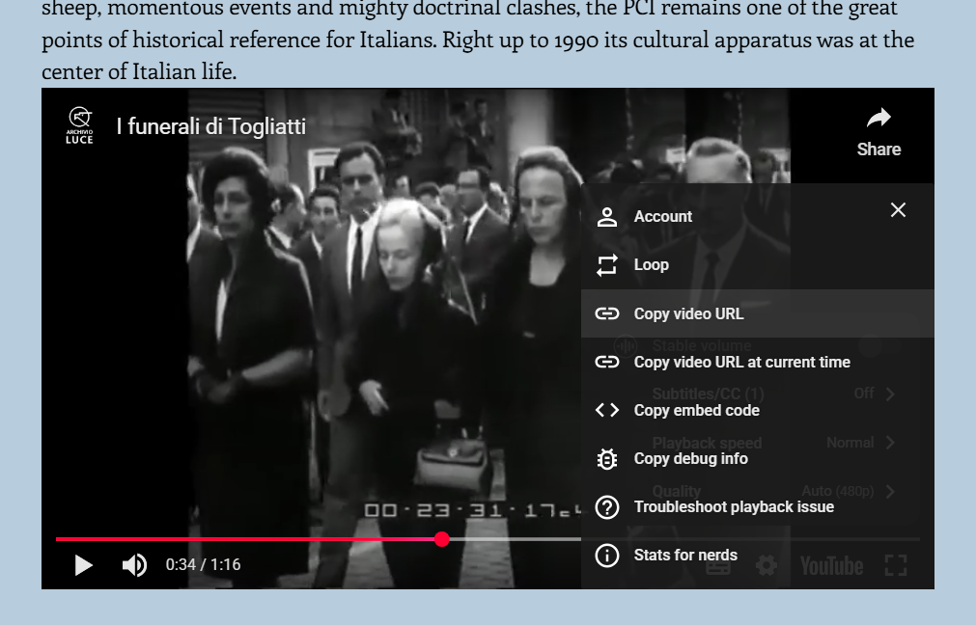
To embed a video, right click on the video and select settings then copy embed code and paste it into the new html or give Claude AI the instruction to do it. Here’s an example from https://www.theberkeleylecce.com/post/tina-modotti-a-blank-face-between-art-and-revolution

To add a picture left with text right and vice versa

Here is an sample html file. Don’t analyse. Instructions to follow.

From the content at this url create a new html in the style of the html I just sent you, using all the associated styling and header placeholder. Add a footer with the date: 16th September 2024. The image is named the-death-of-a-modest=meteor-alice-munro2. Please include the accreditation from the url. The html file should be named 'the-death-of-a-modest=meteor-alice-munro' with the title "The Death of a Modest Meteor, Alice Munro”. When you deliver the file also give me the total number of words in the articles paragraphs. The url is: https://www.theberkeleylecce.com/post/the-death-of-a-modest-meteor-alice-munro

My Istanbul – one pic image with accreditation
britain-unbuilt – multi-image with accreditations
sally-rooneys-so-polite-people – small last paragraph and links to external pages
tina-modotti-a-blank-face-between-art-and-revolution – video
jim-and-james-on-the-big muddy – also video
elaine-matricide-or-oedipal-cuddle – superscripts
patience gray – writing above image, image left justified with citation
tabucchi – left-justified pic with citation

Important Points in the CSS files
Index (Home Page) banner specifications
Components CSS – for mobiles – lines 42 and 62

Title Text in Headers

